Fanny Sanín:

The Balance of Color

September 21, 2016 – November 6, 2016

Acrylic No. 1, 2010, Acrylic on canvas 56 x 60 inches

Acrylic No. 1, 2012, Acrylic on canvas 44 x 42 inches
Acrylic No. 2, 2013, Acrylic on canvas 34 x 40 inches

Acrylic No. 5, 2009, Acrylic on canvas 44 x 42 inches
(In Office Space)
“Study for Painting No. 5(4), 2009, ”Size (framed): 19 3/4 x 18 ¾ inches

“Study for Painting No. 2(3), 2008” Size (framed): 19 x 17 ¼ inches

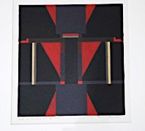 “Study for Painting No. 2(2), 2002” Size (framed): 22 x 18 inches

“Study for Painting No. 1(3), 2002” Size (framed):18 3/4 x 22 3/4 inches

Composition No. 4, 1992 ,Acrylic on paper, 24.5 X 32 inches
(In Office Space)

